Assessment – 1
DSA05 – Query Processing for Data Science
CO1 - Assessment Tool 1 - Data Interpretation
S. Sharon Surya
192324246

- Convert CSV into JSON Given student.csv Task Convert CSV data into JSON format.

Program:
Convert CSV into JSON Given student.csv Task Convert CSV data into JSON format
CSV:
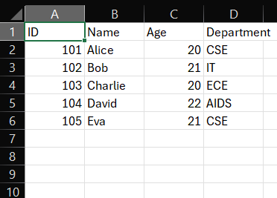

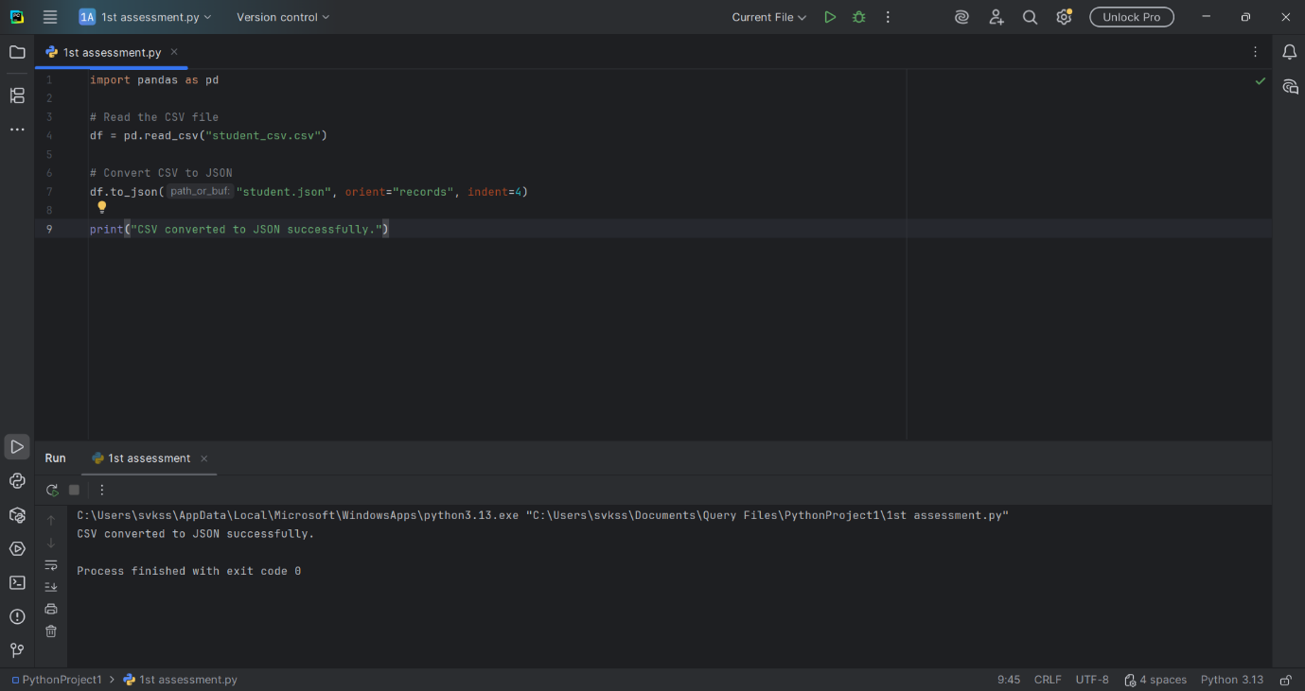
import pandas as pd
df = pd.read_csv("student.csv")
df.to_json("student.json", orient="records", indent=4)
print("CSV converted to JSON successfully.")

Output:

JSON FORMAT:
